Yearling available for syndication 2011
Bay Filly by Beat Hollow ex Paradise Dancer
 |  |  | Northern Dancer | Nearctic
Bay Filly - 20th Jan 2010 |  | Sadlers Wells | Northern Dancer | Natalma
 |  | Sadlers Wells | Fairy Bridge | Bold Reason
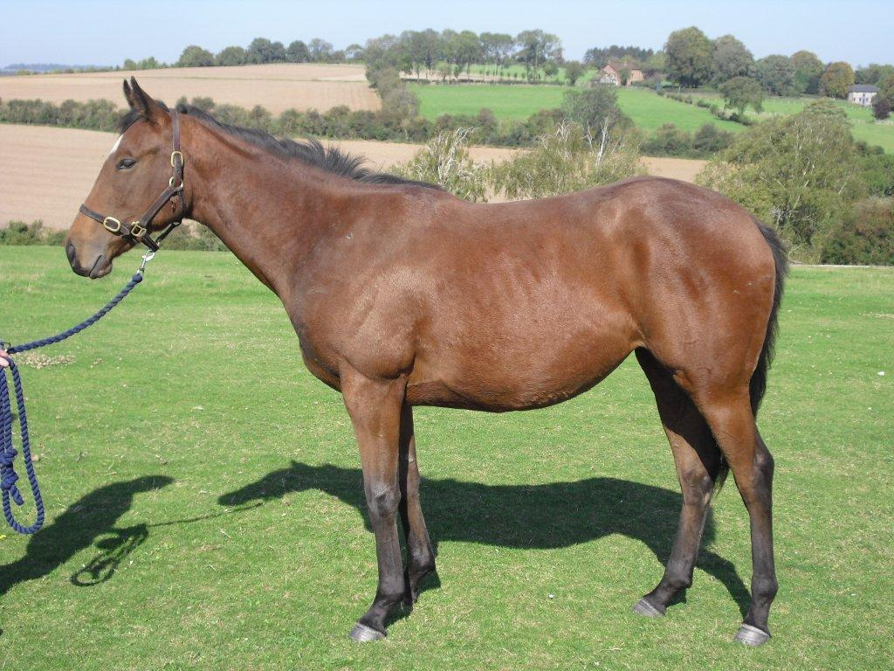 | Beat Hollow |  | Fairy Bridge | Special
 | Beat Hollow |  | Dancing Brave | Lyphard
 |  | Wemyss Bight | Dancing Brave | Navajo Princess
 |  | Wemyss Bight | Bahamian | Mill Reef
 |  |  | Bahamian | Sorbus
 |  |  | Danehill | Danzig
 |  | Danehill Dancer | Danehill | Razyana
 |  | Danehill Dancer | Mira Adonde | Sharpen Up
 | Paradise Dancer |  | Mira Adonde | Lettre D’amour
 | Paradise Dancer |  | Marigan | Blushing Groom
 |  | Pintada de Fresco | Marigan | Madelia
 |  | Pintada de Fresco | Pronancy | Procida
 |  |  | Pronancy | Divona

This un-named filly (stable name Prancer) is a strong & athletic, very similar in stamp to Perfect Tribute. She is likely to be a mid-season two year old but as most horses by Beat Hollow’s she is likely to improve with age. She moves well and has a laid back disposition. Her dam won over a mile, similar to the average winning distance of her sire, Danehill Dancer (8.2). Beat Hollow won over a mile at two years and was best over 10 furlongs at 3 to 5 years.

Beat Hollow is an extremely well- bred sire being by the great Champion and Classic sire, Sadler’s Wells out of the Champion 3 year old filly in Ireland and winner of the Classic Irish Oaks, Wemyss Bight, herself a sister to the dam of Oasis Dream. Beat Hollow was the top rated 3 year old in France and was third in the English Derby. At 5 he won three Group 1 races including the Arlington Million. He won over 1.25 million in prize money. He retired to stud in 2003 and to date he has sired the winners of over 325 races worth £3 million in prize money. He is the sire of 8 individual juvenile stakes performers including the Prix Marcel Boussac winner, Proportional. He is currently the leading sire of 3year olds in Europe with 32 winners from 63 runners and the leading sire by percentage winners to runners in the leading UK and Ireland list (34/83 = 41%).

Paradise Dancer is a large, easy moving, winning mare by the Champion sire, Danehill Dancer. He was the Champion two year old in Ireland winning the Phoenix and National Stakes. He retired to stud in 1997 and to date has sired the winners of over 1800 races worth over £37 million. Paradise Dancer’s dam is a Stakes winner and Stakes placed mare winning three races at two and three and £48,931.

Comments from independent valuer “Sadlers Wells and his sons have crossed well with Danehill line mares including Frankel and Teofilo. Beat Hollow is an impeccably bred son of Sadlers Wells who has produced the stakes winner Rhythm of Light out of a Danehill mare.” Value £20,000

Cost of a 1/8th share (There are 4 x 1/8th shares and 2 x 1/16th shares remaining to be sold)
Year 1 = £5,500 payable as follows £2,500 for a 1/8th share in horse plus £1,500 being 50% of the estimated annual training costs payable at purchase and the remaining £1,500 (50% of the estimated training costs) on 1st May 2012
Year 2 = £3,000 adjusted for extraordinary costs and prize money, payable in two equal instalments in October 2012 and April 2013

The horse will be insured at her purchase price. She will either be sold or valued for distribution of proceeds purposes in October 2013. The name of the filly and trainer will be decided by the joint owners when all the shares have been sold

