Yearling available for syndication
Chestnut Colt Singspiel ex Flamjica
 |  |  | Sadler’s Wells | Northern Dancer
Chestnut Colt - 10th March 2010 |  | In the Wings | Sadler’s Wells | Fairy Bridge
 |  | In the Wings | High Hawk | Shirley Heights
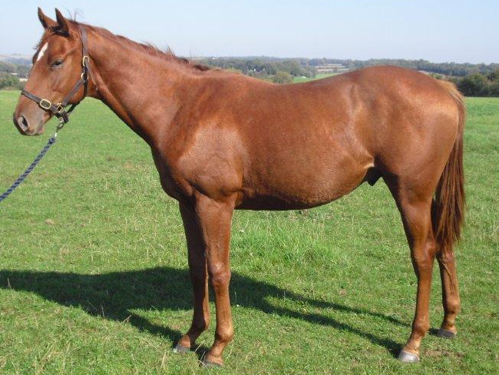 | Singspiel |  | High Hawk | Sunbittern
 | Singspiel |  | Halo | Hail to Reason
 |  | Glorious Song | Halo | Cosmah
 |  | Glorious Song | Ballade | Herbager
 |  |  | Ballade | Miss Swapsco
 |  |  | Quiet American | Fappiano
 |  | Real Quiet | Quiet American | Demure
 |  | Real Quiet | Really Blue | Believe it
 | Flamjica |  | Really Blue | Meadow Blue
 | Flamjica |  | Irish River | Riverman
 |  | Fiamma | Irish River | Irish Star
 |  | Fiamma | Florie | Gay Mecene
 |  |  | Florie | Figure Libre

The above colt is well grown with plenty of substance and scope. He is athletic and is likely to be a late season two year old and a better three year old. He will not go into training until April, May at the earliest and then maybe only to be backed and cantered a way. We will re- assess him at that stage and decide if he will stay in training or come home to give him more time to mature.

He was one of the last crop of the great sire, Singspiel. He was exceptional in every way commanding a stud fee of £50,000 in his early years at stud. He won the Gr1 Grand Prix de Paris and was 2nd in the Eclipse at three, the Japan Cup, and Canadian International at four and The Dubai World cup, Coronation Cup and the Juddmonte International at five adding up to over £3 million in prize money. He retired to stud in 1998 and has sired the winners of 1260 races worth over £36 million in prize money. He was more likely to sire a Timeform 100+ rated horse than Pivotal, Oasis Dream, Dansili or Danehill Dancer, no wonder the average price of his 276 yearlings is over £60k.

Flamjica was purchased as a two year old. She was third first time out in a Newmarket maiden and ran creditable in a Group 3 next time. She followed up by being second in another Newmarket maiden but fractured her hock following which it was difficult to keep her sound. Flamjica is by the Champion three year old, Kentucky Derby and Preakness winner, Real Quiet. She is out of the Listed placed mare, Fiamma, who is a half sister to the Lancashire Oaks winner, Fanjica. She is the dam of Higher Game, a Gr 3 winner and Japanese Derby 3rd.

Comment from independent valuer “Flamjica is a well- bred Fappiano ( Mr Prospector) line mare, whose dam was by Irish River. Singspiel is a world class Sadlers Wells line stallion. Sadlers Wells over Fappianno has produced Group 1 winners CANDY DOLL and SIMPATICO BRIBON and Sadlers Wells over Irish River has produced several Group 1 winners, including SADDEX, SEQUOYAH (herself dam of dual Guineas winner, HENRYTHENAVIGATOR by Mr Prospector’s son Kingmambo,” Value £18,000.

Cost of a 1/8th share (There are 3 x 1/8th shares available)
Year 1 £4,850 payable as £3,550, on agreement to purchase and £1,300 on the 1st May 2012
.
Year 2 £3,000 adjusted for extraordinary costs and prize money won, also payable in two equal instalments in October 2012 and April 2013.

Note: The horse will be insured for £18,000 and sold in October 2013 when the proceeds will be distributed between the owners

